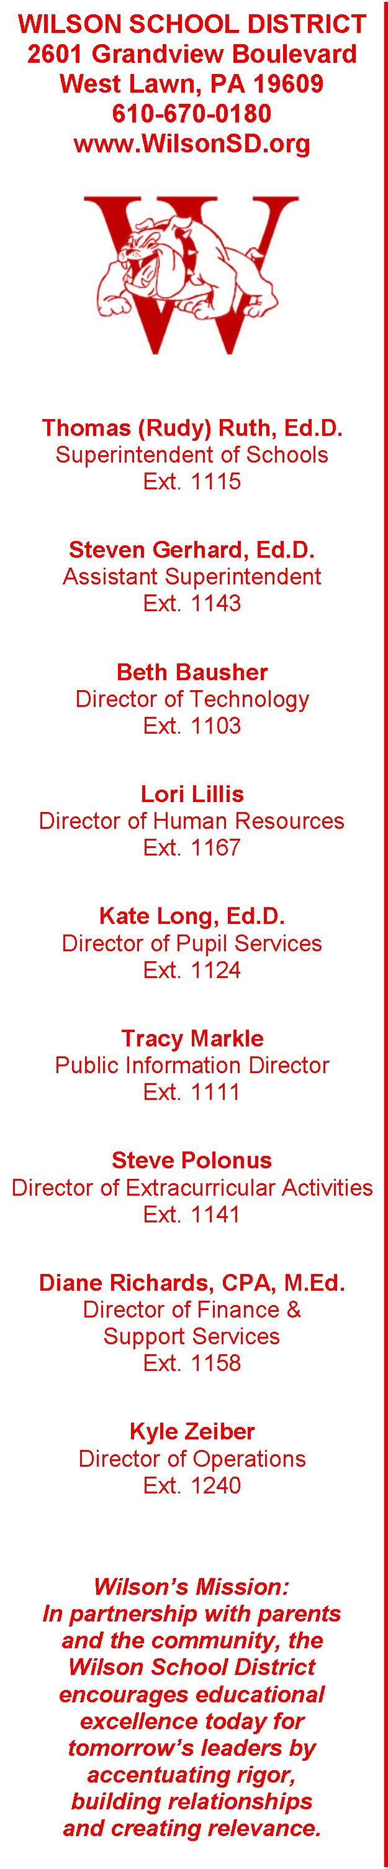

Dear School Volunteer,

The Wilson School District wishes to thank you for your dedicated service to the children of our District by providing your time and talents to the educational process.

As the safety of our children is of utmost importance, the Wilson School Board of Education has adopted a new policy for all school volunteers. As you have been identified as a Short–Term Volunteer, i.e. volunteer on an infrequent basis, have limited contact with students and are always supervised by a District employee, I have enclosed a copy of Board Policy No. 916 - School Volunteer Policy, for your information and reference.

At your earliest convenience, would you please complete the attached Volunteer Acknowledgement Form and return it to the office of the building in which you volunteer or to the district’s Human Resources Office, 2601 Grandview Boulevard, West Lawn, PA 19609.

Once again, we appreciate your willingness to volunteer in our schools. If you have any questions or concerns regarding this new policy, please feel free to contact me.

